**Software Engineering Assignment**

**MODULE: 1**

**SE – Overview of IT Industry**

1. What is software? What is software engineering?

* Software is a collection of program, data and instruction related to it.it can be executed to perform specific task for user and makes particular task easy. software can perform any task by giving instruction to hardware.
* Software engineering is a building block of software.it is about using specific rules and tools to plan, create, and maintain computer programs and apps. Just like how architects plan and build houses, software engineers plan and build software. They make sure the software works well, does what it's supposed to do, and can be updated easily. It's all about making digital stuff that works smoothly and makes life easier for people using computers and devices.

1. Explain types of software

* Application software-

This type of software is designed to perform specific tasks or provide functionality for end-users. Examples include word processors, web browsers, email clients, and video games. Application software is what users interact with directly to accomplish their goals.

* System software-

System software serves as an intermediary between hardware and application software. It includes operating systems, device drivers, utilities, and other tools that manage computer hardware resources and provide a platform for running application software. Operating systems like Windows, macOS, and Linux are examples of system software.

* Driver software-

Driver software, often referred to simply as drivers, is a type of system software that enables communication between hardware devices and the operating system. Drivers allow the operating system to control and utilize hardware components such as printers, graphics cards, and network adapters.

* Middleware-

Middleware is software that acts as a bridge between different systems, applications, or components. It provides services and functionality that facilitate communication, data management, and integration between disparate systems. Examples of middleware include web servers, application servers, message brokers, and database middleware.

* Programming software-

Programming software, also known as development tools or software development kits (SDKs), is used by developers to create, debug, and maintain software applications. This category includes integrated development environments (IDEs), compilers, interpreters, debuggers, and other tools that assist in the software development process.

1. What is SDLC? Explain each phase of SDLC

* SDLC stands for Software Development Life Cycle. It's a process used by software development teams to design, develop, test, and deploy software applications.
* Phases

1. Planning: In this phase, project goals, timelines, and resources are defined and allocated, setting the foundation for the development process.

2. Analysis: This phase involves studying the project requirements, identifying stakeholders, and understanding their needs to define the scope and objectives of the software.

3. Requirements gathering: The process of collecting, documenting, and validating the functional and non-functional requirements from stakeholders to guide the development process.

4. Designing: In this phase, the system architecture, database design, user interface, and other technical specifications are planned and documented based on the gathered requirements.

5. Implementation: The actual coding and development of the software according to the design specifications, often involving programming, integration of components, and building functionalities.

6. Testing: This phase involves systematically checking the software for defects, bugs, and adherence to requirements through various testing techniques like unit testing, integration testing, and acceptance testing.

7. Maintenance: After deployment, the software enters the maintenance phase where it is monitored, updated, and modified to address issues, accommodate changes, and ensure its continued functionality and performance.

1. What is DFD? Create a DFD diagram on Flipkart

* DFD stands for Data Flow Diagram. It's a graphical representation of the flow of data through a system, illustrating how data is input to, processed within, and output from the system. In a DFD, processes are represented as rectangles, data stores as parallel lines, data flows as arrows, and external entities as squares.

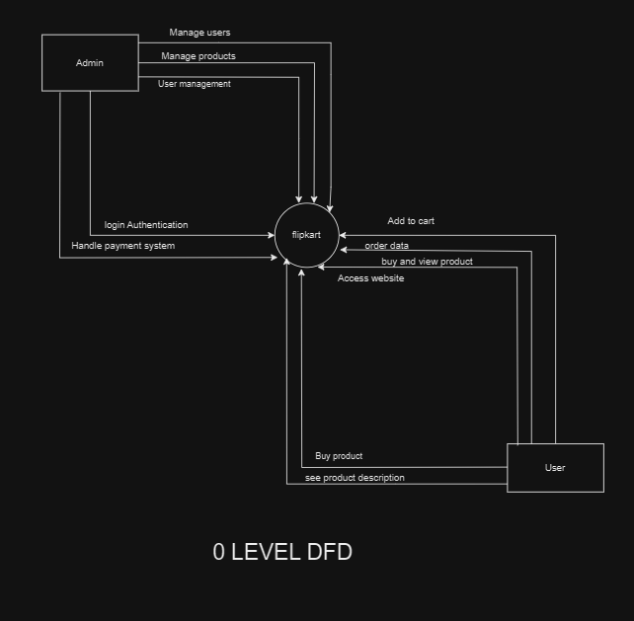

1. What is Flow chart? Create a flowchart to make addition of two numbers

* A flowchart is a graphical representation of a process, showing the steps or actions in sequential order. It uses symbols and connecting lines to illustrate the flow of control or data through the process.

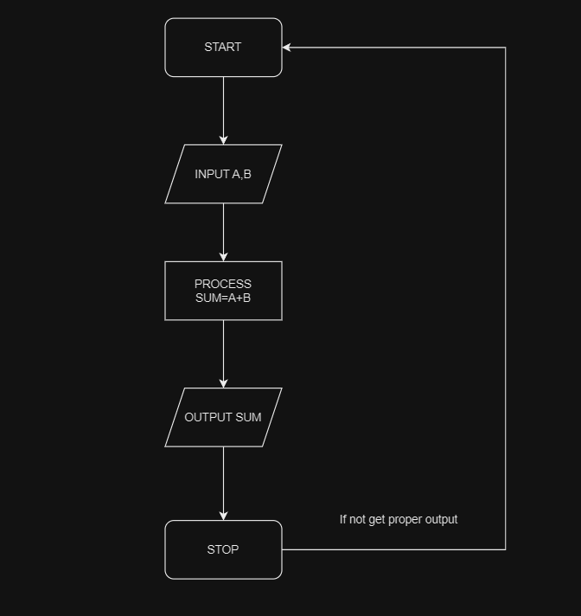

1. What is Use case Diagram? Create a use-case on bill payment on paytm.

* A use case diagram is a type of Unified Modeling Language (UML) diagram used in software engineering to visually represent the interactions between actors (users) and a system. It illustrates the functional requirements of a system by showing how users interact with the system to accomplish specific tasks or goals.

